**Bi-Weekly Report of (Team#10 ) Week #_11_**

**What were the goals for the last 2 weeks?**

**1. [All members] Complete Testing of the Network Synchronization System**

- Goal: We need to ensure all networked components are perfectly synchronized without errors.

- Approach:

- Identify Scenarios: Pin down every critical scenario for network synchronization, including the unusual edge cases.

**2. [Yiel Jang] Refine the Level Design**

- Game Building: Enhance architectural elements, textures, and interactivity.

- Ready Room: Make the waiting area more engaging and user-friendly.

- In-Game Table: Ensure the design supports smooth gameplay and looks great.

- End Session: Craft a clear and memorable conclusion to the game sessions.

**3. [Minseop Lee, Seunghwan Yang] Implement the Core Card Game Mechanics**

- Steps:

- Define Rules: Document all the game rules and mechanics clearly.

- Algorithm Development: Code algorithms for shuffling, dealing, scoring, and enforcing rules.

- Integration Tests: Check that the card engine integrates smoothly with the overall game system.

- User Testing: Run game sessions to collect feedback and tweak the mechanics as needed.

**4. [Minseop Lee, Seunghwan Yang] Design the Card Assets and Architecture**

- Steps:

- Asset Creation: Design both sides of the cards, including the artwork and text.

- Structure the Data: Total 57 number of cards, each card has 8 different 3D symbols.

- Dynamic Loading: Work on efficient loading and unloading of card assets during gameplay.

**5. [Jongeun Park] System-Wide Testing**

- Goal: Perform extensive testing to make sure every component of the game works well together.

- Steps:

- Integration Tests: Focus on how different parts like the card mechanics and network systems work as a unit.

- Stress Tests: Simulate high traffic to understand the system’s limits.

- Usability Tests: Get real users involved to test the game interface and overall user experience.

- Resolve Issues: Address any problems found during testing promptly to stabilize the release.

**What goals were accomplished this week?**

**[Planned goals]**

Implement Network Environment for Multiplayer System

* **[Jongeun Park + all members]:** Implemented a multiplayer environment and confirmed that multiple players can play on a level at the same time. Connected Steamworks API to UE5’s subsystem to handle user session information.

The code defines the AYeppleTownCharacter class, which is a character class for a game called Yepple Town. The class includes functionality for character movement, camera control, and online multiplayer sessions. The character's movement is controlled using the CharacterMovementComponent, with various properties set to define the character's movement capabilities. The camera is attached to a spring arm component, allowing it to follow the character smoothly.

The code also integrates with the Online Subsystem to enable multiplayer functionality. It includes methods for creating, finding, and joining game sessions. When creating a session, the game session settings are configured, such as the maximum number of players, whether to allow joining in progress, and the match type. The code handles session creation, finding sessions, and joining sessions using delegates and callbacks.

The character's input is handled using the Enhanced Input system. The SetupPlayerInputComponent method binds actions for jumping, moving, and looking at the corresponding input events. The Move and Look methods are called when the respective input actions are triggered, updating the character's movement and camera rotation based on the input values.

Refining Level Design

* **[Yiel Jang, Jongeun Park]:** Implemented the main level design using the purchased assets. Modular design allowed flexible development of gameplay processes.
* **[Yiel Jang, SeungHwan Yang]:** Develop and finalize the prototype main level design for the 3D pixel game, focusing on the Colosseum environment. This involves layout planning, aesthetic detailing, and initial functionality testing.

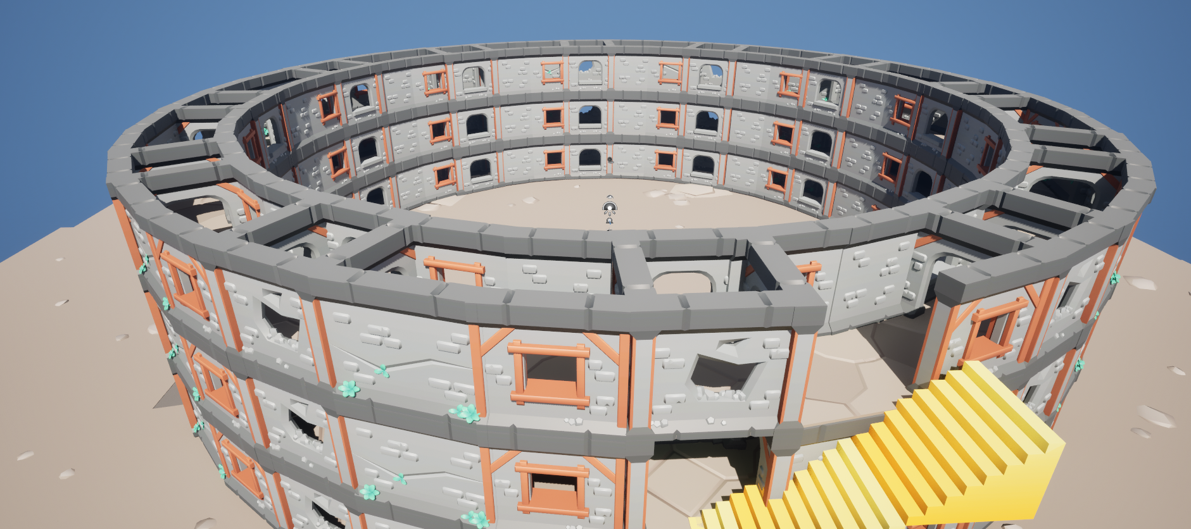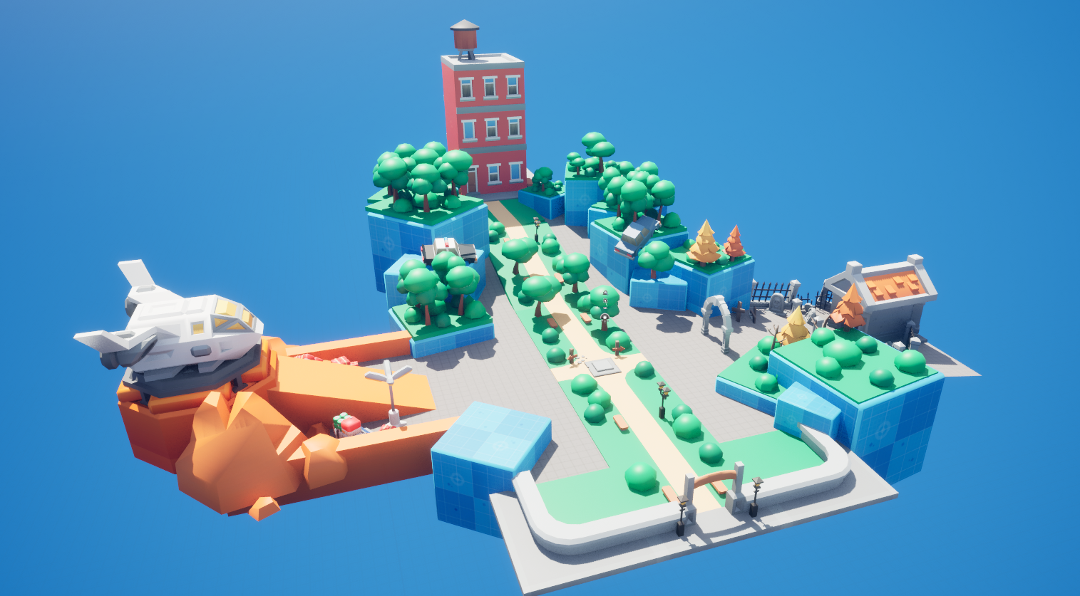

**[Non-planned goals]**

Implement Main Algorithm of Game ‘Dimensional Reduction’, created Timer system for entering Level for multiplayer users.

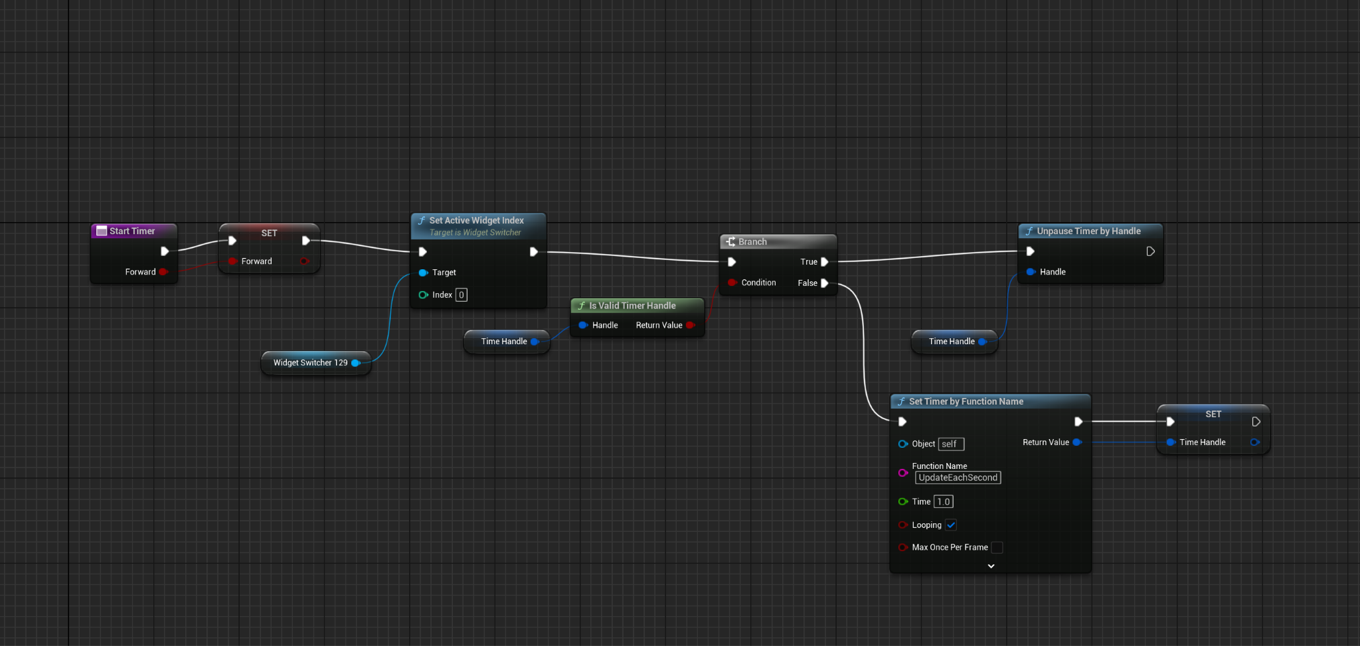

Timer set logic

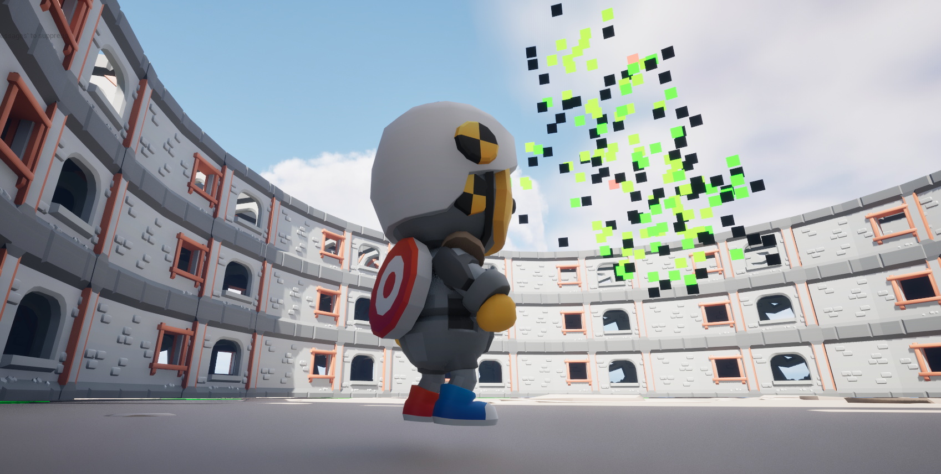

* **[Minseop Lee, Seunghwan Yang]:** Implemented voxel scattering algorithm for 3D pixel game, and created base level design. After importing the image, read the value of each pixel and use vector calculations to determine the size and angle of each pixel cube to be spawned. Below are two main functions for the minigame. Rest of the logics are written in both blueprints and codes.

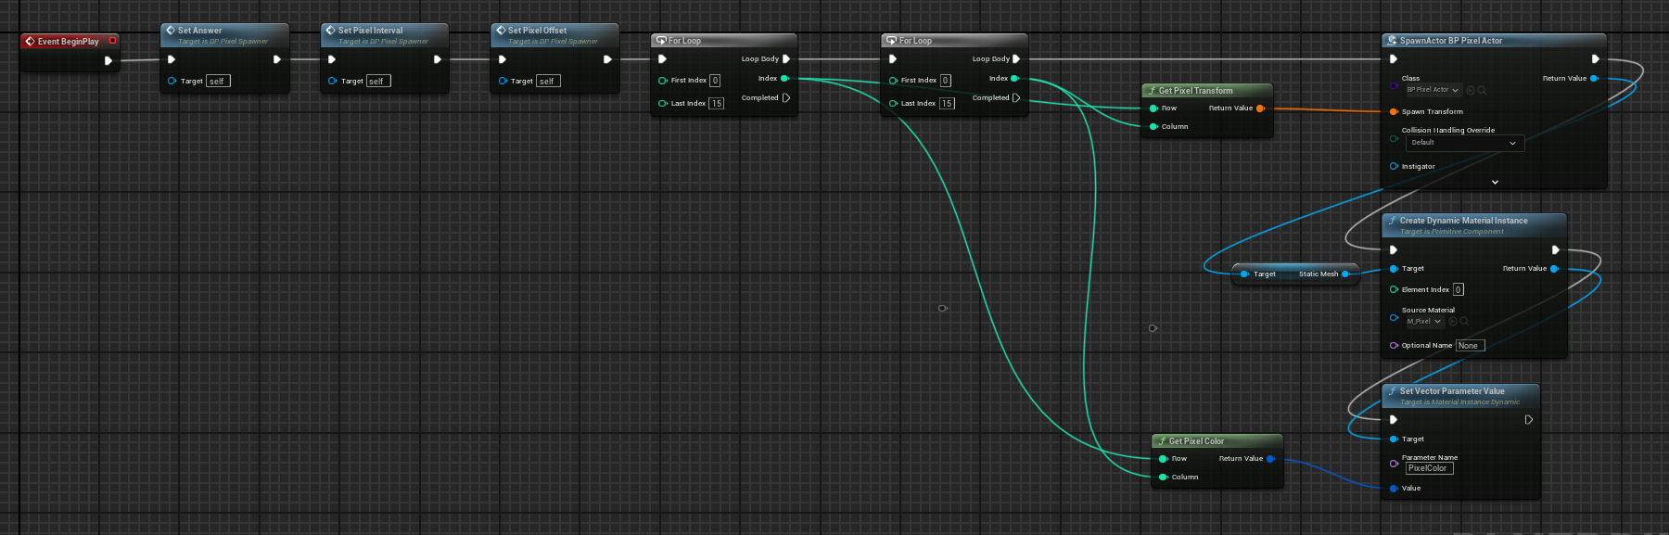

Base Event Graph with other custom functions

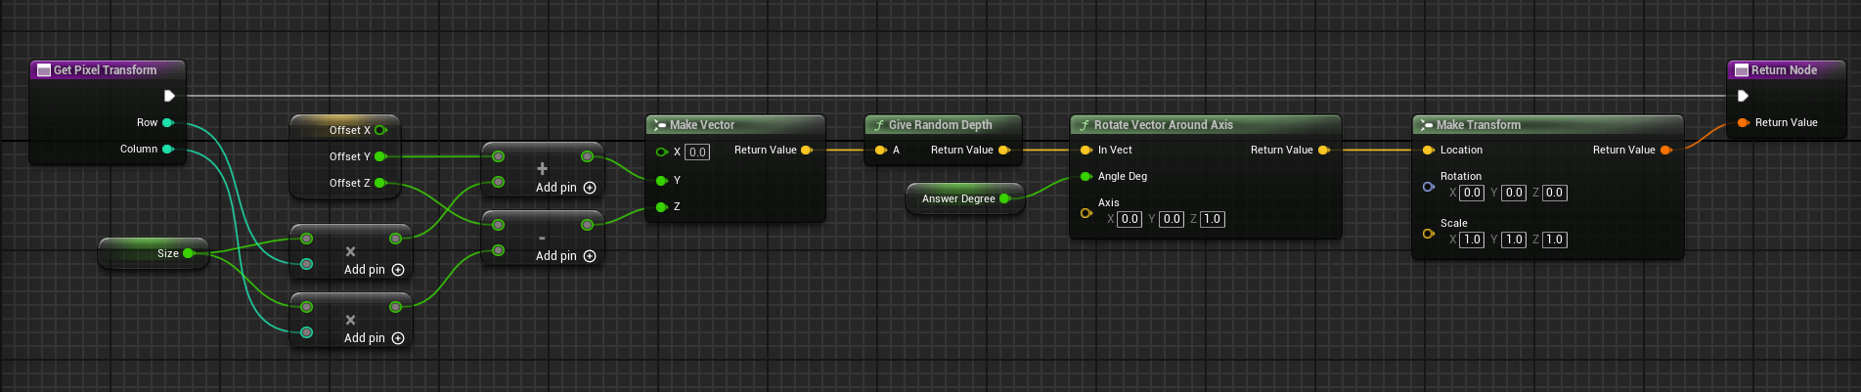

Get Pixel Transform

Test New Player Asset Animations

* **[Minseop Lee, Yiel Jang]:** Integrate and test new animations for player assets to enhance visual engagement and gameplay dynamics. This includes testing the animations for fluidity and compatibility with existing game mechanics.

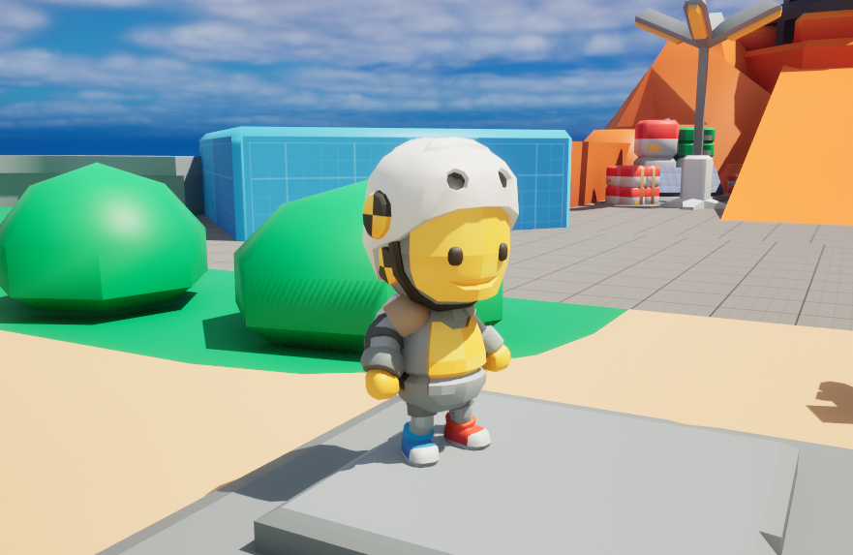

**Reflect critically on any goals not accomplished.**

Ready Room for Main Level Design

* **[Yiel Jang]:** Due to changes in the game level plan, we have decided to directly utilize the current main level without a ready room, transitioning directly to the minigame area.

Card game related plans

* **[Minseop Lee, Seunghwan Yang]:**  Considering the difficulty of implementation, we have decided to prioritize the development of the 3D Pixel game, which is easier to implement. We plan to complete this as quickly as possible and then move on to implementing the card game.

System-wide Testing

* **[Jongeun Park]:** Given the current scale of the game, large-scale testing is challenging. We can be satisfied with confirming that the game runs normally in a 4-player environment.

**What are the goals for next two weeks?**

**1. Enable Multi-Environment Access for the Pixel 3D Game Upon Readiness [Jongeun Park, Minseop Lee]**

* Ensure that once the Pixel 3D game is fully ready, it supports multi-environment access, allowing players from different platforms to join and interact seamlessly.

**2. Implement Mini-game A (Yang’s table, card game) Upon Readiness**

* Develop the algorithm for a card game consisting of 3 rounds and create card-related assets to complete the gameplay mechanism. If possible, port this to a multiplayer environment to finalize it for end-user gameplay.

**How many hours were spent on each goal noted above?**

**[Jongeun Park + all members]**

Complete Testing of the Network Synchronization System: Total Hours: 13 hours

* Identifying Scenarios: 10 hours
* Testing and Debugging: 3 hours

**[Yiel Jang, Jongeun Park]**

Refine the Level Design(partially): Total Hours: 8 hours

* Layout Design: 2 hours
* Game Building: 6 hours

Design Main Level for 3D pixel art game (Colosseum): Total Hour: 10 hours

* Game Building: 6 hours
* Testing Gameplay: 4 hours

**[Minsoep Lee, Yiel Jang]**

Test New Player Asset Animations: Total Hours: 5 hours

* Choose and add animations: 4 hours
* Testing Gameplay: 1 hours

**[Minsoep Lee, SeungHwan Yang]**

Implement the 3D pixel puzzle Game Mechanics: Total Hours: 20 hours

* Defining Rules: 3 hours
* Algorithm Development: 7 hours
* Integration Tests: 5 hours
* User Testing and Tweaks: 5 hours

**[Yiel Jang, SeungHwan Yang]**

Design the 3D pixel puzzle Assets and Architecture(Prototype) : Total Hours: 5 hours

* Finding and buying asset: 2 hours
* Structuring the Data: 3 hours